# Team Name Not Determined

# Meeting Minutes

January 26, 2014

1. **Call to order**

Initial team meeting of the MET CS 473 C1 Software Engineering at 9:00 PM on January 26, 2014 conference bridge.

9:00 PM Conf Dial-in Number: **(530) 881-1000** Pin: **127111#**

For the Conference call please have the Agenda open and be prepared to open the requirements matrix. We can all contribute to these documents at the same time.

Participant: When prompted, enter the assigned access code, followed by the # key.

Once connected to the live conference, every caller will be able to talk. Every caller will also have access to the touch tone commands listed below.

During the free live conference, we will record the call. This will to ensure everyone on the team can listen the the meeting at a later date whether or not you can make the call!

1. **Roll call**

Roll call will be taken at 09:05 PM, each team & individuals will be called:

|  |  |  |  |  |  |
| --- | --- | --- | --- | --- | --- |
| **Team 1** | **Status** | **Team 2** | **Status** | **Team 3** | **Status** |
| Shuran Hang |  | Chris Theberge  Comfortable with ripping off existing UI designs+1 :P, API | x | Lauren Smith  MSSQL, MySQL, JInterested in UI (but not much experience) | x |
| Evan Panahi  Anything except UI design | x | Keith Hale  basic java  basic mysql  basic javascript, php, html | x | Braeden Sanford  Webservices (restful),  Database | x |
| Julia Cheong |  | Charyn Eagan  Management type tasks  UI Design  Basic Java | x | Wail Alghanmi  java backend | x |
| Swapnil Shinde |  | Karen Palmer  interested in UI, strong-ish backend Java  **(Team 2 Lead)** | x | Dan Cusher  no specific strengths, willing to do whatever, solid on Java, basic handle on HTML, CSS, 9 Javascript, mysql | x |
| Rishee Basdeo  -Data modeling  -UI  -API | x | Dan Anderson: Front End, Back End, Database | x | **Jackie Aldama (Team 3 Lead)**  back end java development, some database, front end experience | x |
| Mike Demers  MySQL; HTML/CSS etc | x | Justin Therrien  front end | x | Nik Yusof  Java | x |
|  |  |  |  |  |  |

1. **Closed Tasks**
2. Closed - Communication - conference calls, google docs, email list, etc
3. **Previous meeting Discussion Point 1**
4. Source Control - git
   1. Setup tutorial - Chris (I’ll put together a set of instructions and links)
5. Database server (MySQL) or Postgres
   1. Single Database
   2. Need to have separate meeting to design our model, come with your ER diagrams ready
6. Development Environment (Eclipse)
7. Sunday Meeting 9:00 PM

**Users:**

1. *Service Providers
   1. Food Kitchen
   2. Homeless Shelters
2. *Charity
   1. Individual
   2. Corporate
   3. State rehabilitation programs

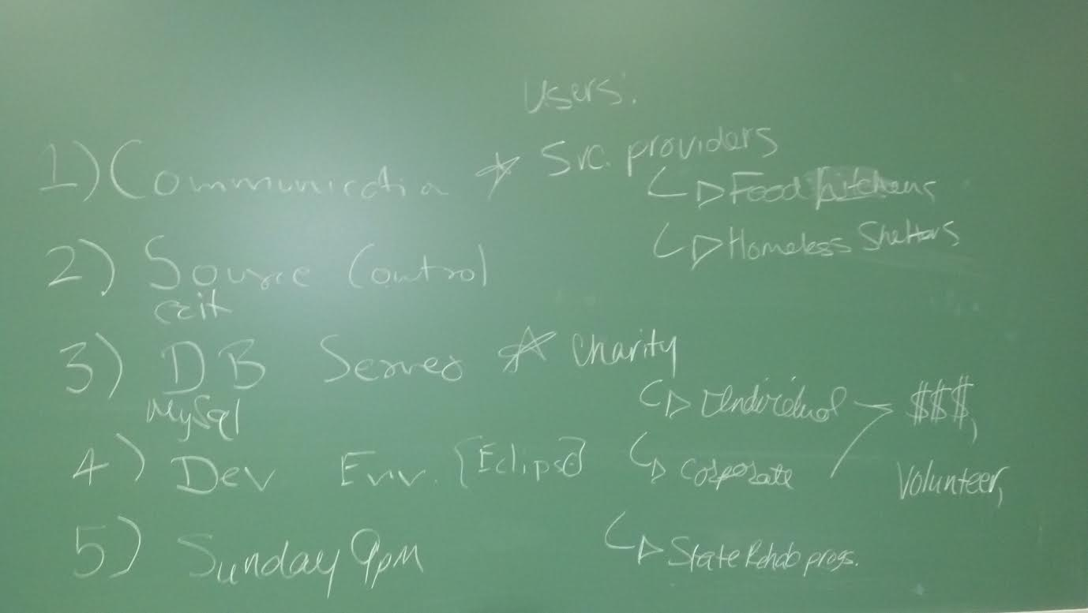

**Previous Discussion Point 2:**

**General Architecture:**

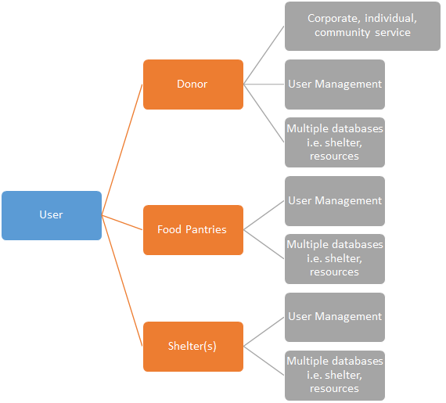

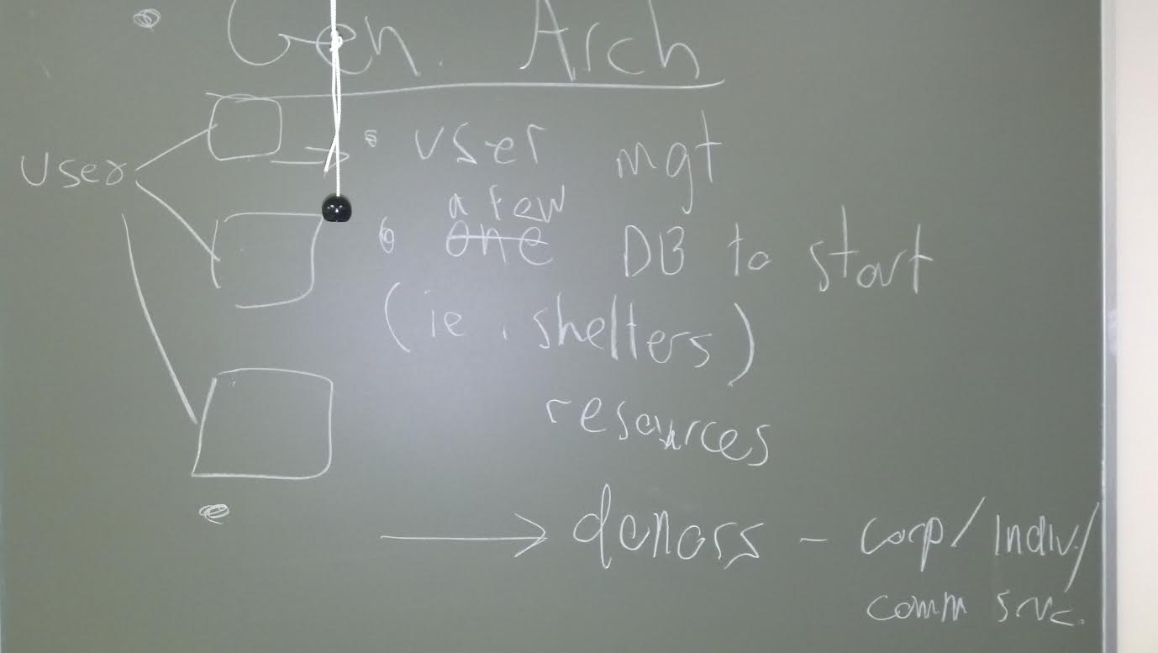

**Open issues/Tasks**

* Draft email to the professor is posted, please review and provide bullets for Karen to send out:

· My Drive -> MET_CS473_C1_Software_Eng_Project -> Common Files -> Meeting Minutes & Agenda

o File Name: 20140126_Draft_Email_to_professor

1. If you missed the call or would like listen to the Free Conference Play Back

· Playback Number: (**530) 881-1099**

Access Code: **127111#**

1. Karen to set up New Survey/Vote for meeting time next week, due to super bowl
2. Follow up with team 1 to determine team lead
3. Identify risks and risk retirement plan. Estimate the time, make initial coarse granularity schedule of iterations. Define quality metrics and the techniques to assure quality. Templates & Drafts to be posted by the teams on 2/1/14.

· **Team 1:** My Drive -> MET_CS473_C1_Software_Eng_Project -> Draft Project1 Files

o Due 2/1/14 Create Schedule - Team 1

o Due 2/1/14 Quality Metrics & Techniques - Team 1

· **Team 2:** My Drive -> MET_CS473_C1_Software_Eng_Project -> Draft Project1 Files

o Due 2/1/14 Identify Risks - Team 2

o Due 2/1/14 Risk Retirement Plan - Team 2

o Due 2/1/14 Draft Proposal - Charyn to create template

· **Team 3:** My Drive -> MET_CS473_C1_Software_Eng_Project -> Draft Project1 Files

o Due 2/1/14 Draft SPMP - Need to research what this is all about - Team 3

o Due 2/1/14 Draft SQAP - Team 3

Finalize the Architecture and the three parts of the project, assign teams to each, any recommendations to change the project categories are welcome, <https://drive.google.com/#my-drive>please include your name with the recommendation to discuss during call:

* Donor(s)
* Food Pantries
* Shelters

1. Initial Planning Phase (Week 1-3)From Software Engineering Project Assignments posted by Ronald E Czik [rec@bu.edu](mailto:rec@bu.edu)

1. Form teams, designate team leaders, other leader roles and responsibilities for each role. Designate a backup for each leader if possible. Set up communication plan.

* Complete - Form Teams
* Need volunteers for team leaders
  + Designate leader backups
* Roles & Responsibilities
* Create Communications Plan - Karen/Charyn to post template
  + The professor wants us to reference sources
* Create test communication plan - Karen/Charyn to post template
  + The professor wants us to reference sources

2. Brainstorm the requirements of the project with the customer. Define the project title and a project vision, including purpose of the application, major functionalities and requirements etc. Research related work, describe the challenges, explore feasibility and learn tools. Draft project proposal.

* Brainstorm the requirements
* Define the project title/Vision
* Research related work (Review other websites for related works)
  + Keith, Rishee, and Charyn to research other websites
* Draft Project Proposal

3. Set up development environment. We will use Java and Eclipse as the IDE. You can either use SVN or /GIT as version control tool. You can use Google code (code.google.com/hosting/) or github (https://github.com) to host your project. All documents and code should be configuration items and stored in your version control system.

* Setup Development Enviornment
  + Development Environment should not matter, each team will be submitting the .java files into source control
* Version Control recommendations - Chris (Tutorials, Links, Github Organization)

4. Identify risks and risk retirement plan. Estimate the time, make initial coarse granularity schedule of iterations. Define quality metrics and the techniques to assure quality.

SPMP and SQAP.

* Identify Risks - Team 2
* Risk Retirement Plan - Team 2
* Create Schedule - Team 1
* Quality Metrics & Techniques - Team 1
* Draft SPMP - Need to research what this is all about - Team 3
* Draft SQAP - Team 3
* Draft Proposal - Charyn to create template

5. Reference: please read book Section 3.3 (P55-59) for team guidance on initial team meeting, communication plan, and test communication plan. Also read hints on team exercises on P61. Please read book Section 7.7 (P162-165) for team guidance on team organization, meeting. Please read book Section 5.9

(P103-117) for the case study of Encounter SQAP. Please read book Section 8.7 (P208-210) for the team guidance on steps to a project management plan, and Section 8.4 (P187-196) for the case study of Encounter SPMP.

* Project management plan

6. Submission: Proposal, SPMP, SQAP, presentation.

* Final Proposal
* Final SPMP
* Final SQAP

1. **Create Organizational Chart**
2. The teams have been selected: (please let me know if there are any concerns)

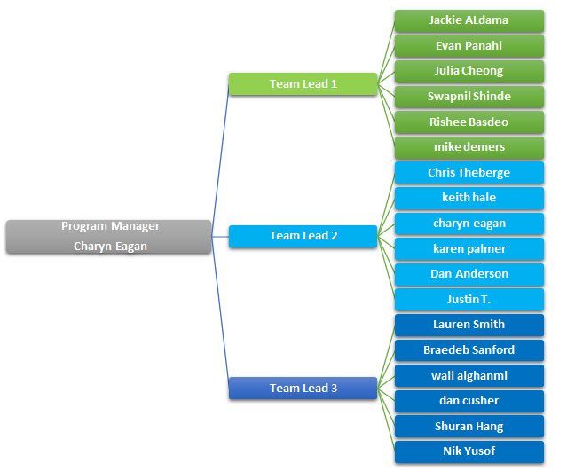

1. **Figure 1 Organizational Chart**